APPLIED RESEARCH STATIONS AND NEW BEAM TRANSFER LINES
AT THE NICA ACCELERATOR COMPLEX*
A. Slivin†, A. Agapov, A. Baldin, A. Butenko, G. Filatov, A. Galimov, S. Kolesnikov, K. Shipulin, E. Syresin, A. Tikhomirov, G. Timoshenko, A. Tuzikov, V. Tyulkin, A. Vorozhtsov, Joint Institute for Nuclear Research, Dubna, Russia
T. Kulevoy, Y. Titarenko, Institute for Theoretical and Experimental Physics of National Research
Centre “Kurchatov Institute”, Moscow, Russia
D. Bobrovskiy, A. Chumakov, S. Soloviev, Specialized Electronic Systems (SPELS) and National
Research Nuclear University (NRNU) “MEPHI”, Moscow, Russia
A. Kubankin, Belgorod State University, Belgorod, Russia
P. Chernykh, S. Osipov, E. Serenkov, Ostec Enterprise Ltd, Moscow, Russia
S. Antoine, W. Beeckman, X. Guy Duveau, J. Guerra-Phillips, P. Jehanno, A. Lancelot, SIGMAPHI S.A., Vannes, France
I. Glebov, V. Luzanov, LLC “GIRO-PROM” (GIRO-PROM), Dubna, Russia

* Work supported by grant for young scientists. Unique id 21-102-09
† slivin@jinr.ru

Abstract
An applied research at the NICA accelerator complex includes following areas under construction: an applied research for capsulated microchips for single event effects testing (energy range of 150- 500 MeV/n) at the Irradiation Setup for Components of Radioelectronic Apparature (ISCRA), an applied research for decapsulated microchips for single event effects testing (ion energy up to 3,2 MeV/n) at the Station of CHip Irradiation (SOCHI), and an applied research for space radiobiological research and modelling of influence of heavy charged particles on cognitive functions of the brain of small laboratory animals and primates (energy range 500-1000 MeV/n) at the Setup for Investigation of Medical Biological Objects (SIMBO). Description of the main systems and beam parameters at the ISCRA, SOCHI and SIMBO applied research stations is presented. The new beam transfer lines are being constructed between Nuclotron and ISCRA and SIMBO stations, and between HILAC and SOCHI station. Description of the transfer lines layout, the magnets and diagnostic detectors, results of the beam dynamics simulations are described.

INTRODUCTION
NICA (Nuclotron-based Ion Collider fAсility) is a new accelerator complex being constructed at the Laboratory of High Energy Physics of the Joint Institute for Nuclear
Research [1]. Within the framework of the NICA project, it is planned to create three experimental stations for conducting applied researches with accelerated long-range ion beams extracted from the Nuclotron, and accelerated short-range ion beams extracted from the heavy ion linear accelerator (HILAC) [2].

NEW BEAM LINES IN MEASUREMENT HALL OF VBLHEP JINR
Two new areas are organized within the framework of the NICA applied research program.
Special area 1 includes beam channel (Fig. 1) to SOCHI station.
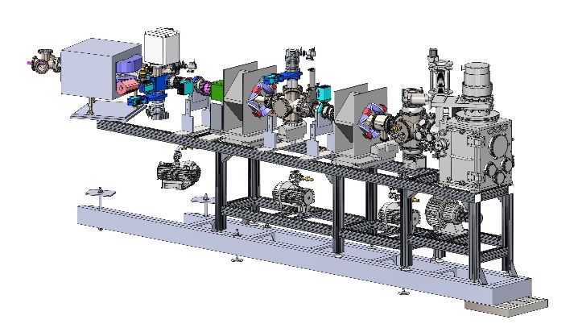
Figure 1: SOCHI beam channel design.
Special area 2 includes two beam channels to SIMBO and ISCRA stations. Beam channels are being developed as part of the JINR-SIGMAPHI collaboration. These channels will be integrated into the existing Nuclotron-to-VP-1 extraction beam line (Fig. 2).
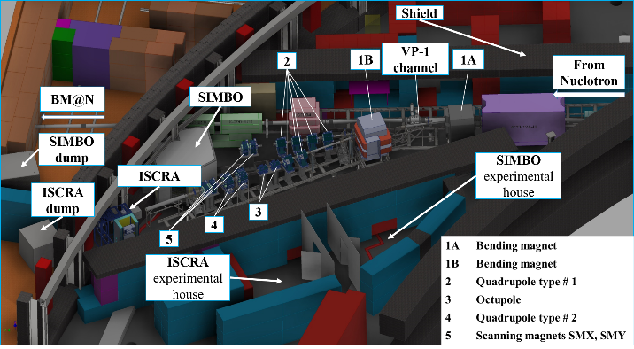
Figure 2: Area 2 infrastructure layout.
beam dynamics simulations
One of the main conditions required for irradiation of samples is the beam distribution homogeneity at the target area.
In the SOCHI channel, a 73-mm-wide beam is shaped by quadrupole magnets. The beam envelope in the SOCHI beam line is presented in [3].
In the ISCRA channel two octupole magnets are required to shape the beam profile in the non-scanning mode. The particles distribution on the target was calculated by tracking of 5×10⁵ particles in the MAD-X program (Fig. 3).
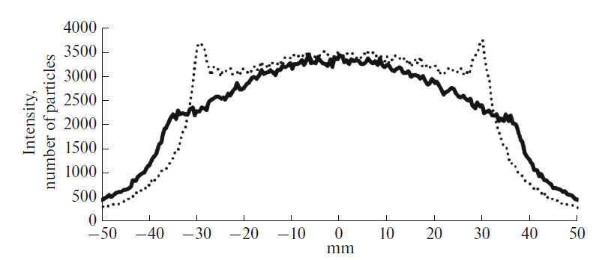
Figure 3: Transverse particle distribution in the horizontal (dotted) and vertical (solid) planes on the target as a function of transverse coordinates.
At the SIMBO station, in addition to quadrupole magnets, a collimator with an adjustable inner diameter from 10 mm to 100 mm will serve to provide a sharp boundary of the irradiation field area in both scanning and non-scanning modes.
Magnet System of the new beam lines
The design and manufacturing of new magnets (Table 1) with their supports and power supplies for scanning magnets is being developed as part of the JINR-SIGMAPHI collaboration.
In addition to the existing dipole magnets that serve to direct the beam from the Nuclotron to the channels [4], the ISCRA and SIMBO channels will be equipped with new scanning magnets, two new families of quadrupoles and new octupole magnets. For the SOCHI channel, two existing quadrupole magnets similar to those in the HILAC-Booster transfer line are used [5].
The magnets are presently under manufacturing at SIGMAPHI; the delivery to JINR is planned for summer 2022.
Table 1: Main Requirements on the New Magnet for the
ISCRA and SIMBO Channels
 | Scanning | Quadrupole |  | 8-pole
Parameter | SMX/SMY | Type 1 | Type 2
# magnets | 2+2 | 6 | 2 | 2
Gap/bore Ø (mm) | 140 | 108 | 160 | 105
Field/Gradient (T, T/m, T/m³) | ±0.8 | 0.6-5.4 | 0.2-1.4 | 1098
L_{eff} (mm) | 356±4 | 492±2 | 480±2 | 505±3
Good Field Region (mm) | H×V  60 x 60 | Ø 100 | Ø 128 | Ø 90
Rel. integrated field error ×10⁻³ | < ±5 | < ±5 | < ±5 | < ±5
Operating mode | Scanning  f=0.5-3 Hz | DC | DC | DC
Detectors
There are three types of detectors will be used for beam diagnostics in the beam channels in the Measurement Hall: an offline multiwire proportional ionization chamber (1 pcs. 100×100 mm and 2 pcs. 75×75 mm), scintillation-fiber detector (1 pcs. 100×100 mm and 2 pcs. 75×75 mm) and two systems for online diagnostics (4 scintillation-fiber based detectors 20×20 mm). The offline systems duplicate each other to get more reliable results. The diagnostics and corrector system of the HILAC-Booster channel will be used to control the beam in the SOCHI channel [5]. Beam diagnostics in each of the beam channels will be in conjunction with the beam diagnostics at the stations.
The ion beam diagnostics and control systems of applied stations should be duplicated by the type of detector. All detectors should be placed on stepper motors that transversely move and withdraw detectors from the beam area. The diagnostics equipment is designed to measure and control such beam characteristics as the ion flux density, ion fluence, ion beam linear energy transfer (LET), mean energy, beam profiles, and absorbed dose [6].

SOCHI APPLIED RESEARCH STATION
The SOCHI station (Fig. 4) is designed to research and test promising semiconductor micro- and nanoelectronics products for determination of SEE sensitivity to low energy heavy charged particles at the exit from the HILAС.
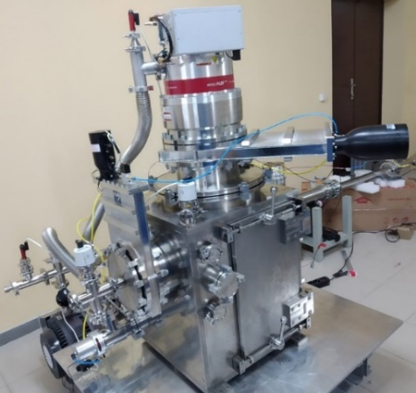
Figure 4: General 3D view of the SOCHI station.
Table 2 shows the sufficient ion beam parameters for the planned work.

Table 2: Technical Requirements for the Ion Beams at the SOCHI Station
Ion types | ¹²C⁴⁺, ⁴⁰Ar⁸⁺, ¹³¹Xe²²⁺, ⁸⁴Kr¹⁴⁺, ¹⁶⁹Tm²¹⁺, ¹⁹⁷Au³¹⁺, ²⁰⁹Bi³⁴⁺
Ion energy at the exit from the  HILac, MeV/n | 3,2
Ion flux density, particles/(cm²∙s) | 10²..3∙10⁵
Maximum irradiation area, mm | Ø29
Beam diameter, mm | Ø73

The equipment for the SOCHI station is being developed as part of the JINR-ITEPh collaboration with participation of SPELS/MEPHI, GIRO-PROM, VST.
The diagnostics system is represented by the following detectors: microchannel plates, system for online diagnostics and control of peripheral ion flux density and fluence (four scintillation-fiber detectors based on multichannel photomultiplier), the fast total-absorption scintillation detector with optical readout, a Faraday cup, fast total absorption phosphor screen. The signals from the detectors are integrated into the general data acquisition system.

ISCRA APPLIED RESEARCH STATION
The ISCRA station (Fig. 5) is designed to research and test promising semiconductor micro- and nanoelectronics products for determination of SEE sensitivity to high-energy heavy charged particles.
The equipment for the ISCRA station is being developed as part of the JINR-ITEP collaboration with participation of SPELS/MEPHI, GIRO-PROM.
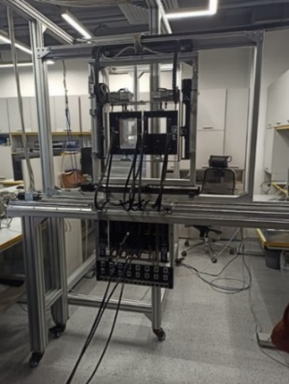 | 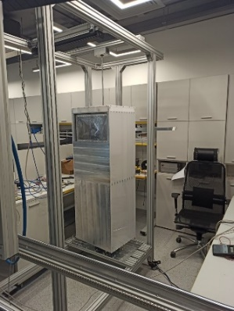
Figure 5: The positioning system of the ISCRA station (left) and energy degrader (right).
Table 3 shows the sufficient parameters of the ion beam for the planned work.
Table 3: Technical Requirements for the Ion Beams at the ISCRA Station
Ion types, energy MeV/n | ¹⁹⁷Au⁷⁹⁺ | 150-350
 | ¹³¹Xe⁵⁴⁺ | 150-367
 | ¹²C⁶⁺ | 150-392
Ion flux density,  particles/(cm2∙s) | 10²..3∙10⁵
Irradiation area in the  scanning mode/nonscanning mode, mm | 200х200/Ø29
Flux uniformity for the  maximum irradiation area in the scanning mode/nonscanning mode, % | 15/10

The diagnostics system is represented by the following detectors: ionization chamber 1, proportional wire ionization chamber 2, miniature gas-filled ionization chamber 3, a scintillation-fiber detector, a silicon detector, an online particle flux density meter based on four scintillators (or four silicon detectors), the absolute measurements of the ion flux density can be performed using 0.1-mm-thick plastic foils as offline detectors at specified points.

SIMBO applied research station
The SIMBO station is designed for radiobiological
research to simulate the effects of heavy charged particles of galactic and solar cosmic rays on the cognitive functions of lower primates and small laboratory animals.
The equipment for the SIMBO station is being
developed as part of the JINR-VST collaboration.
Table 4 shows the sufficient parameters of the ion beam for the planned work.
Table 4: Technical Requirements for the Ion Beams at the SIMBO Station
Ion types | ¹²C⁶⁺, ⁴⁰Ar¹⁸⁺, ⁵⁶Fe²⁶⁺, ⁸⁴Kr³⁶⁺
Ion energy at the exit from the Nuclotron, MeV/n | 500-1000
Ion flux density, particles/(cm²∙s) | 10³..10⁶
Radiation dose, Gy | 1-3
Irradiation area in the scanning mode/nonscanning mode, mm | 100х100/Ø10

The diagnostics system is represented by the following detectors: ionization chamber 1, ionization chamber 2, ionization chamber 3, ionization chamber 4, the thin scintillation counter, a diamond semiconductor detector, the system based on four scintillation detectors for online diagnostics and control.
The mounting and commissioning of the SOCHI station are planned for the autumn of 2021, while the ISCRA and SIMBO stations for spring 2022. First beam experiments at the SOCHI station are planned for spring 2022, experiments at the ISCRA and SIMBO stations are start to autumn 2022.

acknowledgEmentS
Work supported by grant for young scientists. Unique ID 21-102-09.

References
[1] G. Trubnikov et al., “Heavy ion collider facility NICA at JINR (Dubna): status and development”, in Proc. ICHEP’12, Melbourne, Australia, July 2012, pp. 315-328.
doi:10.1142/9789814508865_0042
[2] E. Syresin et al., “New Nuclotron beam lines and stations for applied researches”, in Proc. 10th Int. Particle Accelerator Conf. (IPAC’19), Melbourne, Australia, May 2019, pp. 449-451. doi:10.18429/JACoW-IPAC2019-MOPMP013
[3] G. Filatov et al., “The beam transfer lines for electronics and radiobiology applications of the NICA project”, Proceedings of the 23rd International Scientific Conference Of Young Scientists And Specialists (Ayss-2019), 2019. doi:10.1063/1.5130119
[4] G. Filatov et al., “New Beam Lines for Applied Research at the NICA Facility and Their Beam Dynamics”, Physics of Particles and Nuclei Letters, vol. 17, no. 4, pp. 434–437, Jul. 2020. doi:10.1134/S1547477120040196
[5] A. Tuzikov et al., “Beam Transfer From Heavy-Ion Linear Accelerator HILAC Into booster of NICA Accelerator Complex”, in Proc. 25th Russian Particle Accelerator Conf. (RuPAC’16), Saint-Petersburg, Russia, Nov. 2016, pp. 444–446. doi:10.18429/JACoW-RUPAC2016-WEPSB037
[6] A. Slivin et al., “Development of beam diagnostics systems for applied experimental stations at VBLHEP JINR”, in Proc. AIP, Oct. 2019, vol. 2163, pp. 080007.
doi:10.1063/1.5130122

